A

Mini-Project Report on

## Quiz System

Submitted in partial fulfillment of the requirements for the degree of

BACHELOR OF ENGINEERING

IN

### Computer Science & Engineering

### Artificial Intelligence & Machine Learning

by

Vivek Dalvi (22106168)

Yash Desai (22106005)

Vaibhav Bura (22106067)

Pratik Dhas (22106063)

Under the guidance of

## Prof. Sayali Badhan



### Department of Computer Science & Engineering

### (Artificial Intelligence & Machine Learning)

**A. P. Shah Institute of Technology**

**G. B. Road, Kasarvadavali, Thane (W)-400615**

**University Of Mumbai**

**2023-2024**

## 

## A. P. SHAH INSTITUTE OF TECHNOLOGY

## CERTIFICATE

This is to certify that the project entitled “**Quiz System”** is a bonafide work of Vivek Dalvi (22106108), Yash Desai (22106005), Vaibhav Bura (22106067), Pratik Dhas (22106063) submitted to the University of Mumbai in partial fulfillment of the requirement for the award of **Bachelor of Engineering** in **Computer Science & Engineering (Artificial Intelligence & Machine Learning).**

|  |  |
| --- | --- |
| ________________ | _______________ |
| Prof. Sayali Badhan | Dr. Jaya Gupta |
| Mini Project Guide | Head of Department |

## 

## A.P. Shah Institute of Technology

## 

## Project Report Approval

This Mini project report entitled “**Quiz System*”*** by **Vivek Dalvi, Yash Desai, Vaibhav Bura and Pratik Dhas**is approved for the degree of ***Bachelor of Engineering*** in ***Computer Science &Engineering***, (AIML) ***2023-24***.

##### External Examiner:

##### Internal Examiner:

Place: APSIT, Thane

Date:

**Declaration**

##### We declare that this written submission represents my ideas in my own words and where others' ideas or words have been included, I have adequately cited and referenced the original sources. I also declare that I have adhered to all principles of academic honesty and integrity and have not misrepresented or fabricated or falsified any idea/data/fact/source in my submission. I understand that any violation of the above will cause disciplinary action by the Institute and can also invoke penal action from the sources which have thus not been properly cited or from whom proper permission has not been taken when needed.

|  |  |  |  |
| --- | --- | --- | --- |
| Vivek Dalvi | Yash Desai | Vaibhav Bura | Pratik Dhas |
| (22106108) | (22106005) | (22106067) | (22106063) |

#### ABSTRACT

The Quiz System is a digital platform designed for creating, managing, and conducting quizzes and assessments. It offers a user-friendly interface for quiz creators to author questions, set up quizzes and define scoring rules. Participants can access quizzes, answer questions and receive immediate feedback on their performance. The system also supports various question types, time limits and scoring options, making it adaptable for educational training and entertainment purposes. Furthermore, it includes user authentication, result tracking and analytics features to enhance the overall quiz experience. The Quiz System aims to streamline the process of knowledge assessment and engagement in both educational and recreational settings.

**Index**

|  |  |  |  |
| --- | --- | --- | --- |
| Index | | | Page no. |
| Chapter-1 | | |  |
|  | Introduction | | 1 |
|  |  |  |  |
| Chapter-2 | | |  |
|  | Literature Survey | | 3 |
|  | 2.1 | History | 4 |
|  | 2.1 | Review | 5 |
|  |  |  |  |
| Chapter-3 | | |  |
|  | Problem Statement | | 6 |
|  |  |  |  |
| Chapter-4 | | |  |
|  | Experimental Setup | | 7 |
|  | 4.1 | Hardware setup | 8 |
|  | 4.2 | Software Setup | 9 |
|  |  |  |  |
| Chapter-5 | | | 10 |
|  | Proposed system and Implementation | | 11 |
|  | 5.1 | Block Diagram of proposed system | 12 |
|  | 5.2 | Description of Block diagram | 13 |
|  | 5.3 | Implementation |  |
|  |  |  |  |
| Chapter-6 | | |  |
|  | Conclusion | | 16 |
|  |  |  |  |
| References | | | 18 |
|  |  |  |  |

# CHAPTER 1

# INTRODUCTION

### INTRODUCTION

A quiz system is a modern and comprehensive platform that allows users to create, manage and participate in quizzes. The system supports various question types, multimedia to ensure a dynamic and engaging learning experience. With its emphasis on online learning and assessment, this quiz system brings value and innovation to the educational landscape.

The quiz system mini project is aimed at creating an efficient and user-friendly platform for educational institutions to assess the knowledge and understanding of students in various subjects. The system will allow teachers to create quizzes with multiple choice questions. The system will also track student progress and provide feedback on their performance.

Quiz systems are valuable tools for assessing knowledge, tracking progress and enhancing the learning experience in various settings. This introduction sets the stage for exploring the diverse capabilities and advantages of the Quiz System, emphasizing its role as a transformative tool in the realm of modern education and training.

# CHAPTER 2 LITERATURE SURVEY

#### LITERATURE SURVEY

###### 2.1-HISTORY

The concept of quiz systems dates to the early days of computer-based learning. In the 1960s, computer-assisted instruction (CAI) emerged as a new approach to education, with the goal of using computers to enhance the learning process. One of the earliest examples of a quiz system was developed by IBM in the 1960s. The system, called PLATO (Programmed Logic for Automated Teaching Operations), was used to deliver computer-based instruction to students in schools and universities. Over the years, quiz systems have evolved and become more sophisticated. Today, there are numerous quiz platforms available online, ranging from simple quiz to complex quiz. In recent years, quiz systems have become increasingly popular in educational institutions around the world. They offer a convenient and efficient way to assess student knowledge and understanding, while also providing valuable feedback on student performance. The quiz system mini project builds on this tradition by creating a modern, user-friendly platform that is designed to meet the needs of today's educators and students. With its focus on simplicity, accessibility, and effectiveness, the quiz system mini project is composed to become an essential tool for educational institutions everywhere.

#### 2.2-LITERATURE REVIEW

1. A Novel Online quizzing system for blind people by implementing modern voice recognition techniques

Author: Vikas Karma, Alankrita Singh, Priyanshi Sharma, Ritu Yadav

Publisher: IEEE

* <https://ieeexplore.ieee.org/document/10127578/>

Published in 2023 2nd Edition of IEEE Delhi Section Flagship Conference (DELCON).

We integrate the feature of voice recognition that avails the blind people. Our system can ask questions and can record their responses, after which instant feedback will be provided to them.

2. Collaboration with Specialists by introduced the system in international summit.

Author: K. Umeda, T. Yasuda, S. Yokoi

Publisher: IEEE

* <https://ieeexplore.ieee.org/document/1186208/>

Published in International Conference on Computers in Education, 2002. Proceedings.

The purpose of this research is to create a comprehensive multimedia online quiz system on the Web that makes it easy to create and administer a "rich" online quiz, and to reuse and exchange it efficiently with collaboration from specialists such as teachers or curators.

3. “Game Quiz” - Implementing a serious game platform based in quiz games for teaching information and technology.

Author: Vitor Carvalho

Publisher: IEEE

* h[ttps://ieeexplore.ieee.org/document/6784218/](https://ieeexplore.ieee.org/document/6784218/)

Published in 2014 11th International Conference on Remote Engineering and Virtual Instrumentation (REV)

This paper presents an online platform based on serious games, which intends to enhance the interest of these children, leading them into learning.

# CHAPTER 3

# Problem Statement

# To provide a seamless and secure assessment experience for educators, trainers, and learners. The goal is to create a quiz system that promotes accurate assessment, fair evaluation, inclusivity for all learners, personalized learning experiences, and the development of critical thinking skills.

# CHAPTER 4

# EXPERIMENTAL SETUP

# 4.1- HARDWARE SETUP

# 1.Computer:

# You'll need a computer for development and hosting the quiz. It could be a desktop or laptop.

# 2. Internet Connection:

# A stable internet connection is essential for hosting and participating in the online quiz.

# 3. Server:

# Depending on the scale of your project, you might need a server to host the quiz platform.

# 4.2- SOFTWARE SETUP

# 1. Operating System:

# Choose an operating system for your development environment, such as Windows, macOS, or Linux.

# 2. Web Development Tools:

# Text Editor or Integrated Development Environment (IDE). You can use tools like Visual Studio Code, Sublime Text or JetBrains' IDEs for coding.

# 3. Database Management:

# Our project involves storing user data or questions, we need a database server like MySQL, PHP or MongoDB.

# 4. Programming Languages and Frameworks:

# * Backend: Choose a programming language and framework like MySQL, JavaScript and PHP.

# * Frontend: Use HTML, CSS, and JavaScript for the user interface and login page will be look more attractive.

# 5. Quiz Platform Software:

# You may need to develop your own quiz platform or use existing solutions like Moodle, Canvas, or create a custom solution using your chosen programming stack.

# CHAPTER 5

# Proposed system and Implementation

**5.1- BLOCK DIAGRAM OF PROPOSED SYSTEM**

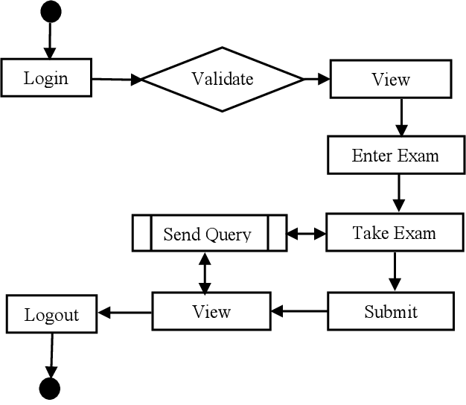

Figure 5.1, flowchart of quiz system

**5.2- DESCRIPTION OF BLOCK DIAGRAM**

**1. Login:**

- This block represents the initial step where users log in with their credentials (username and password).

- It is the entry point to the quiz system.

**2. Validate:**

- After logging in, the system validates the user's credentials to ensure they have the necessary permissions to access the quiz.

**3. View:**

- Once validated, the user can view available quizzes. This block provides a list of quizzes the user can choose from.

**4. Enter Exam:**

- When a user selects a quiz, this block allows them to enter the chosen exam or quiz. It prepares the environment for the quiz to begin.

**5. Take Exam:**

- This block represents the main quiz interface where users answer questions and interact with the quiz content.

**6. Submit:**

- After completing the quiz, the user can submit their answers for evaluation. This block handles the submission process.

**7. View (again):**

- Users can view their quiz results or feedback on their performance in this block.

**8. Send Query:**

- If a user has any queries or issues, this block allows them to send a message or query for support or clarification.

**9. Logout:**

- Finally, the user can log out of the system to end their session securely.

**5.3- IMPLEMENTATION**

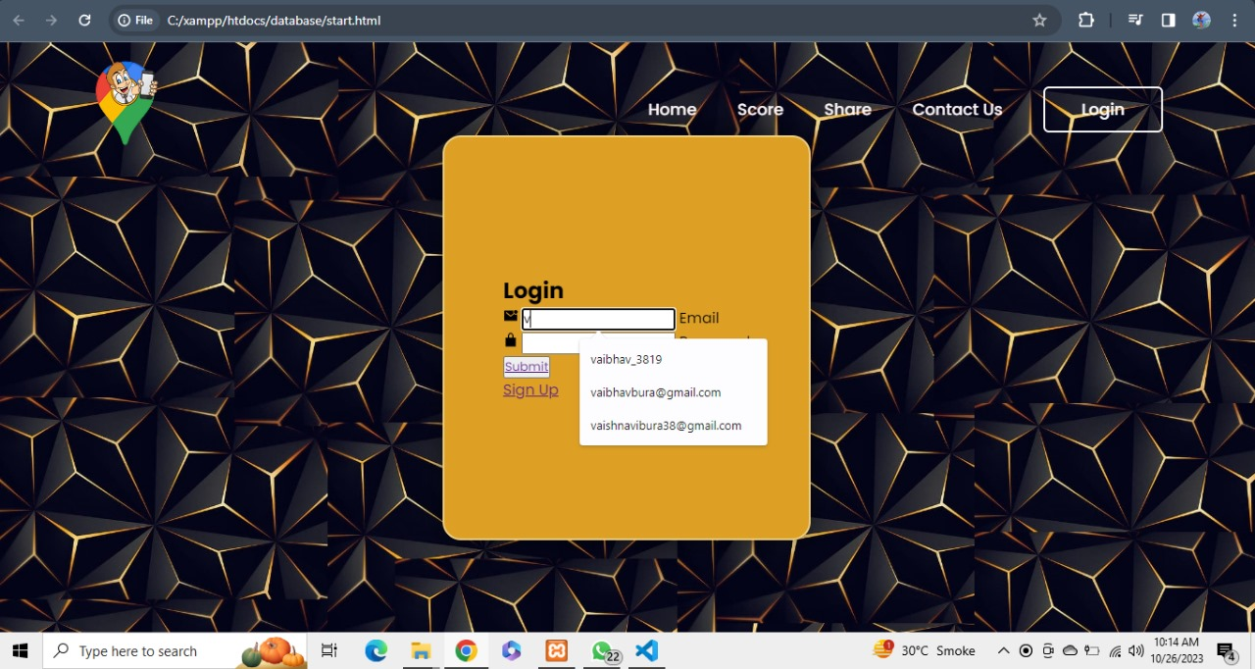

Figure 5.2, login page of quiz system

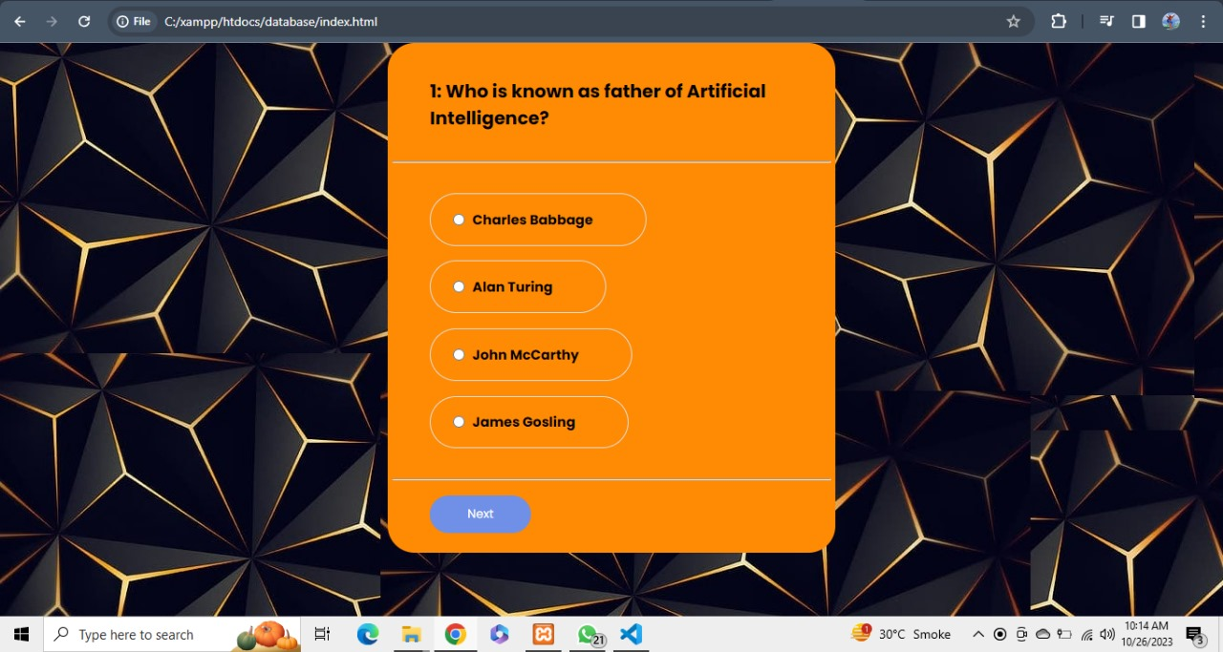

Figure 5.3, Question page for quiz system

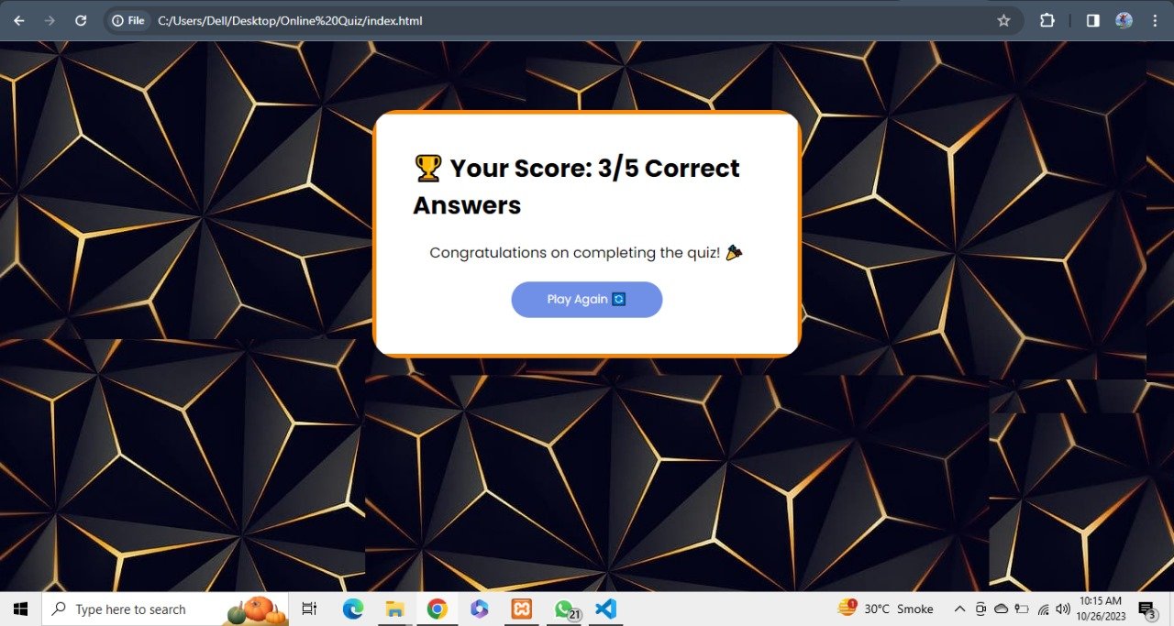

Figure 5.4, scorecard of quiz system

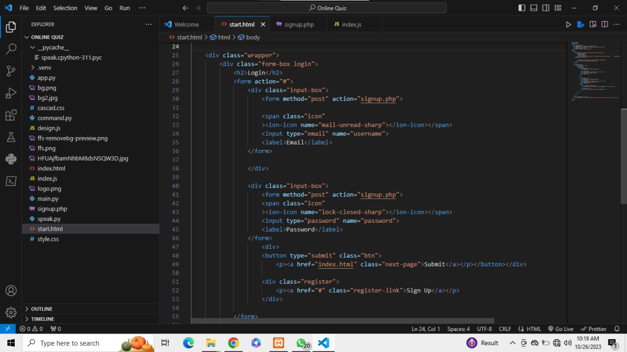

Figure 5.5, Code of quiz system

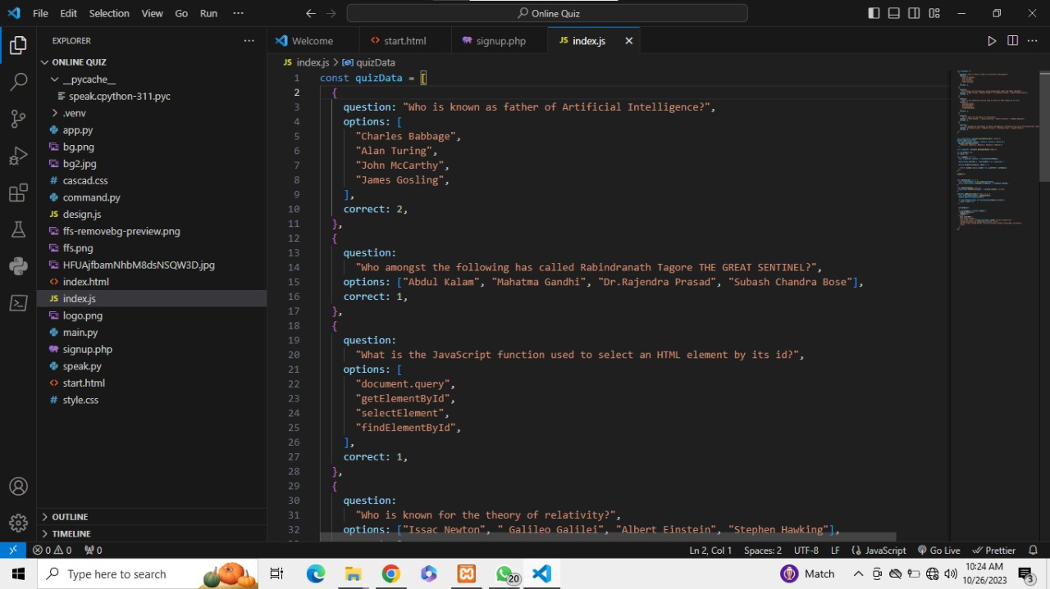

Figure 5.6, Code of quiz system

**CHAPTER 6**

**CONCLUSION**

**6.1- CONCLUSION**

1. **User Experience**: The user experience of the quiz system is crucial for its success. A user-friendly interface, intuitive navigation, and responsive design contribute significantly to user engagement and satisfaction. These aspects must be continually monitored and improved to ensure an optimal experience.
2. **Content Management:** The system's content management capabilities are central to its functionality. Efficient content creation, editing, and management are essential for maintaining up-to-date and relevant quizzes. Integrating tools for content creation and revision is vital for long-term success.
3. **Security**: Protecting user data and maintaining the integrity of the quiz results is of utmost importance. Implementing robust security measures and adhering to data protection regulations is critical.
4. **Future Directions:** As technology evolves and user needs change, it is crucial to remain adaptable and responsive. The quiz system should continue to evolve, incorporating new features and technologies to stay relevant and competitive.

**REFERENCES**

* <https://ieeexplore.ieee.org/document/10127578/> [1]
* <https://ieeexplore.ieee.org/document/8769530/> [2]
* <https://ieeexplore.ieee.org/xpl/conhome/9453798/proceeding> [3]